On Website .com Menu
More – TallyMaster – Chili Results Approval

Enter the cook off to approve – Click Search
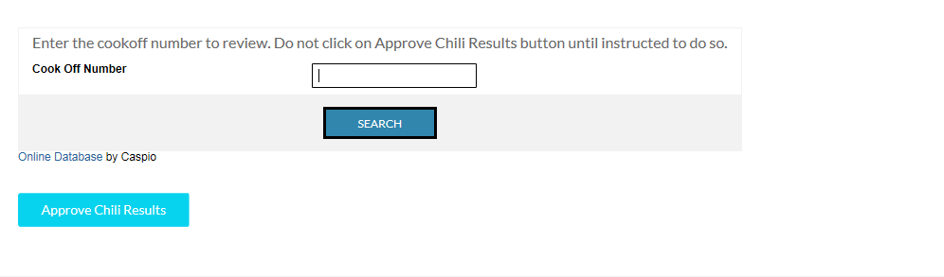

Review the cook off results. Click view to make any changes and click Approve Chili Results when finished.

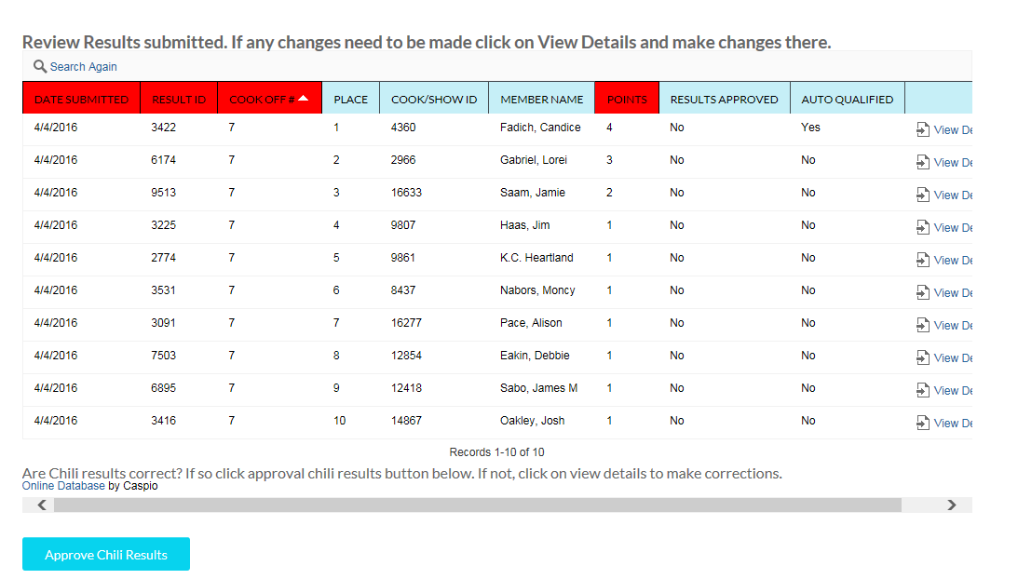
Do the same for show results

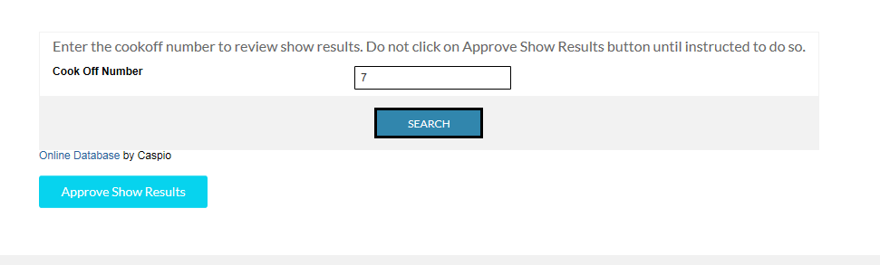

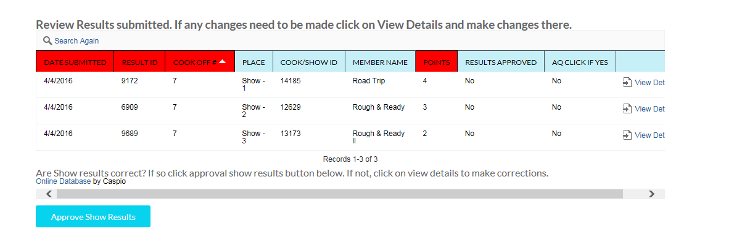

After you click Approve Show Results complete the payment record by clicking on View Details

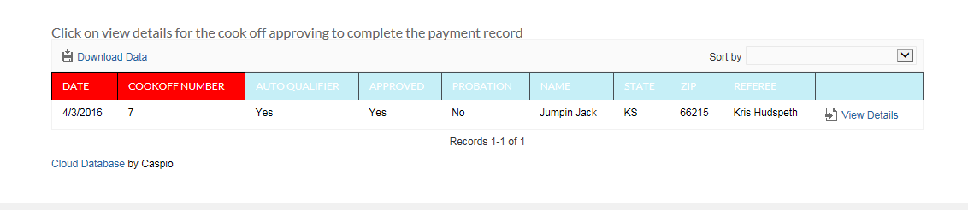

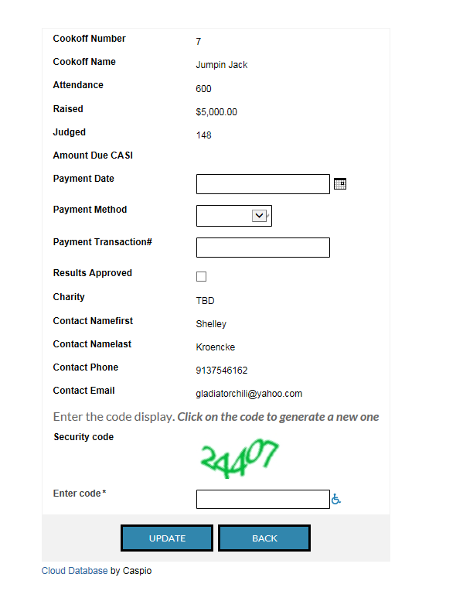

Once payment record is complete enter the cook off number to update the cooks qualification status

Enter the cook off number you just approved and click search. DO NOT click Update Show Qualification Status until instructed to do so.

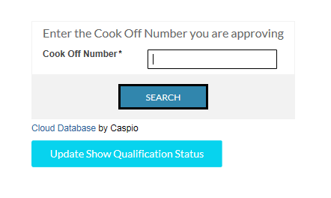
If the cook has a yes in Cook Qualified? Or Cook Auto Qualified click on the Grid Edit

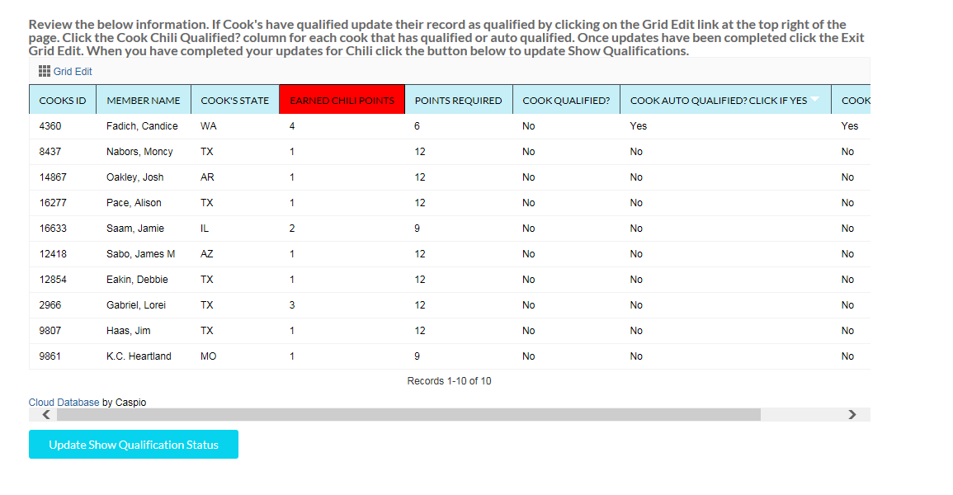

And click the box next to their record to set them as Qualified. If there is already a check in the box there is no need to make a change for that record.

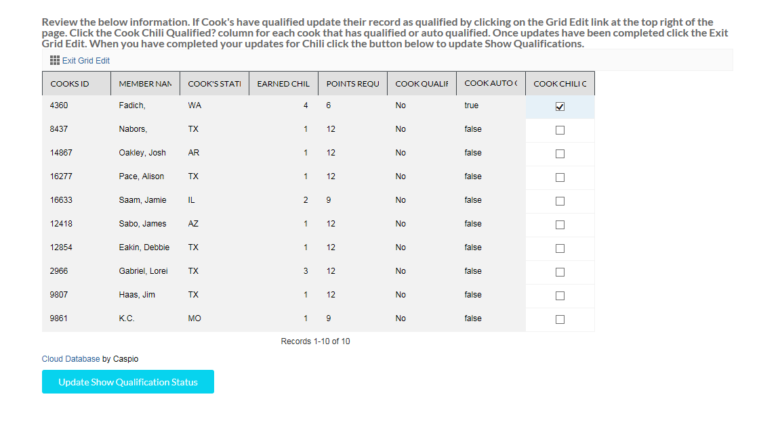

Do the same for Show. DO NOT click Exit Results until instructed to do so.

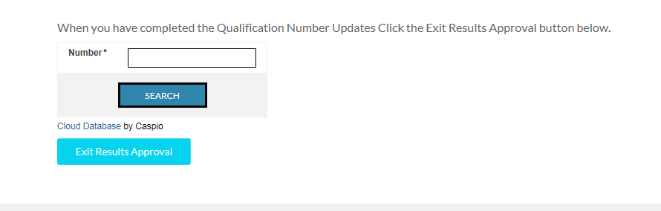
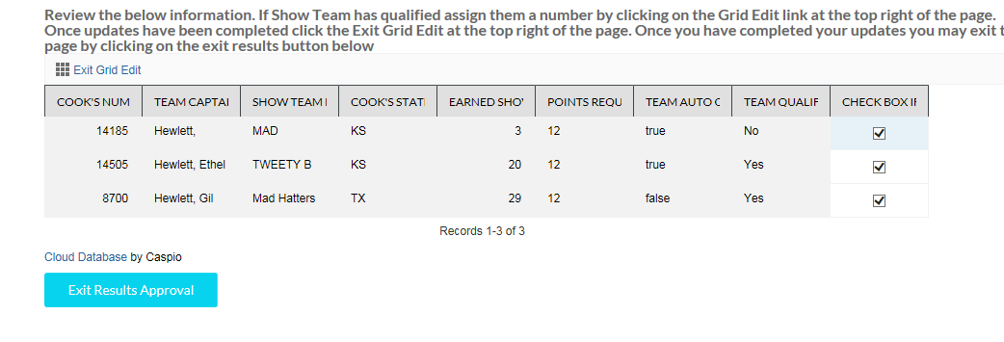
After this step the instructions at the top of the step state to click Exit Results Approval once you have finished and clicked the Exit Grid Edit.
Now go to TallyMaster menu and select Chili Q# Update. If a cook has qualified since you did the results their record will show. Click update and then submit on the next record. This assigns their Q# and will send them an email notification. If there are more records it will kick to each until complete. If there are no records to begin with it will state no records found.

For testing purposes if there is an email address please remove it from the record so it does not accidently send one to them. You can put in your email address if you want to see what the notice is.

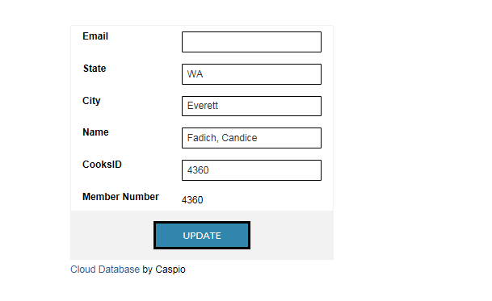

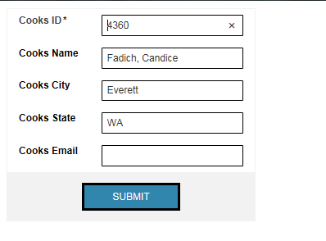

Do the same for Show by going to the TallyMaster menu Show Q# update
