Website – www.casichili.com
Go to the menu item Membership Coordinator and select Create your Membership Profile.
You will see the below for logon. Enter your credentials and click the Login button

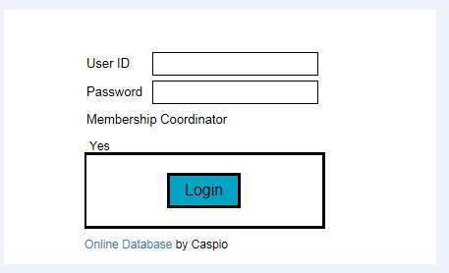

Enter all or at least all required fields in the form. Required fields are marked with a red *
Click the Submit button once complete.

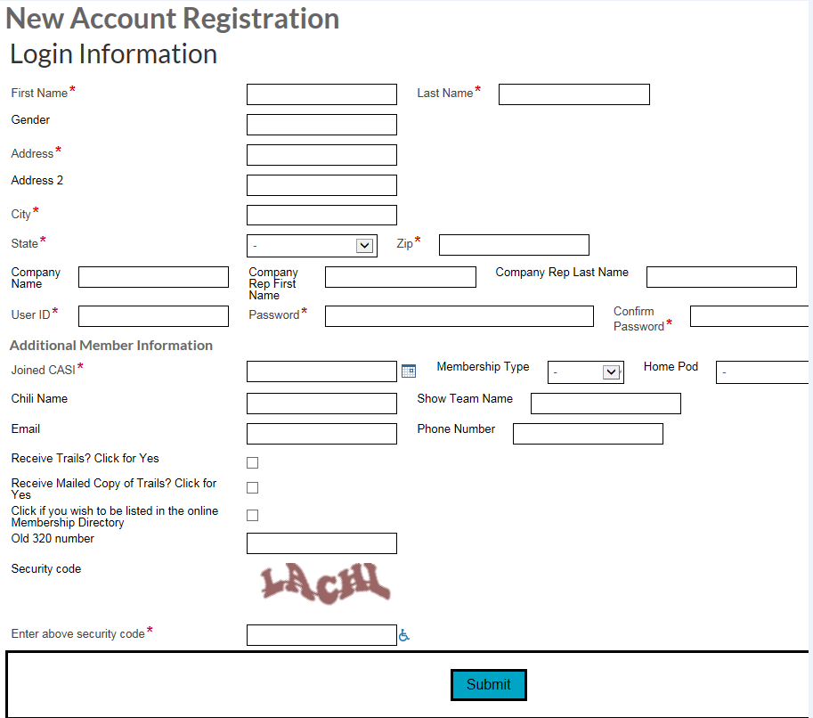

You have now be directed to the member payment record. Complete the payment record information and click the Submit button. You will be directed back to the Membership Coordinator webpage once you click submit.

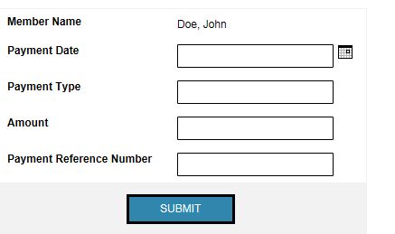

To update a member’s record go to the same menu item, Membership Coordinator and choose the Member Update.
Search for the Member Record by using any of the below. If you use the expiration it is set to be a Less than or equal to date. 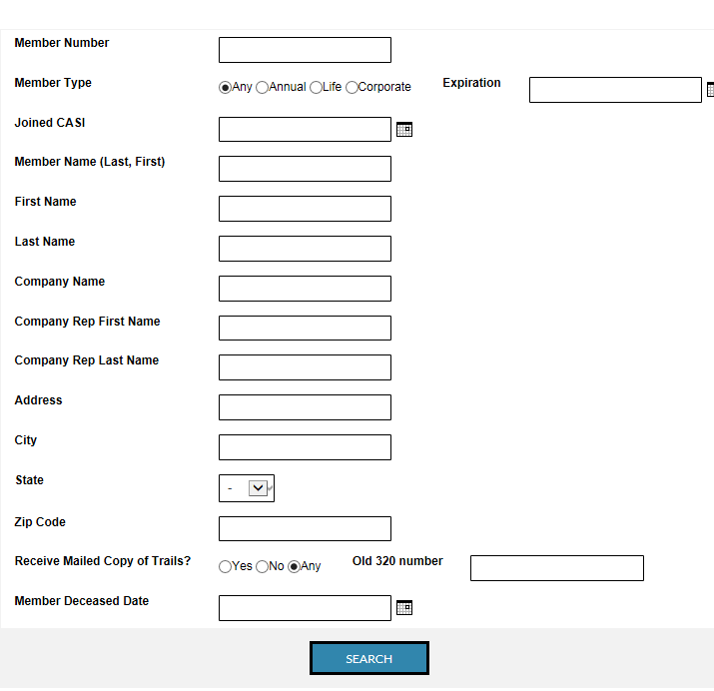

Click on the view details link next to the record you want to change.

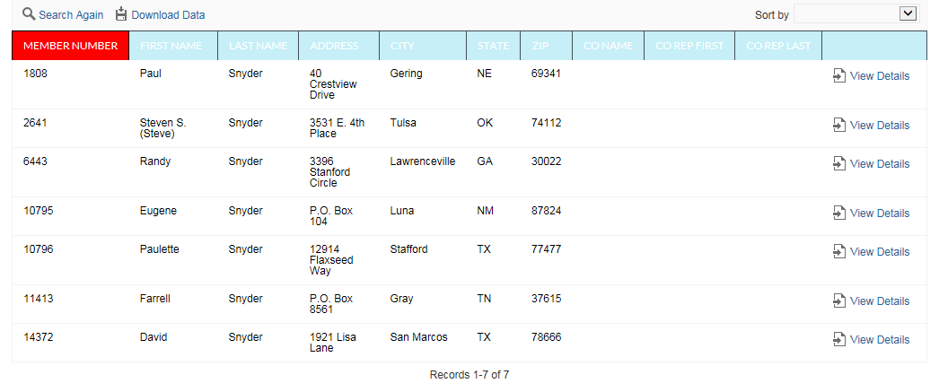

Make all necessary changes and click the Update button.

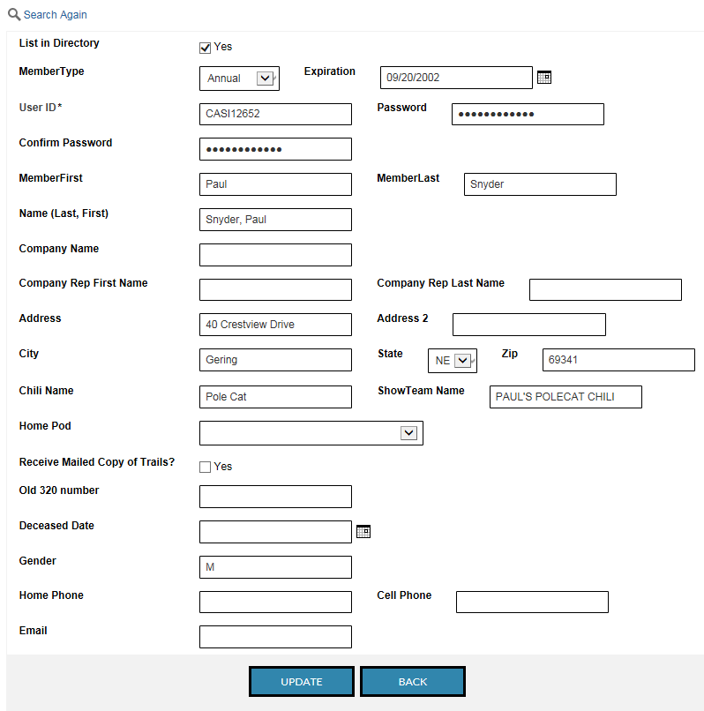

To update the payment record go to the Membership Coordinator and select Update Payment Record.
Enter the Members Name in the format of Last, First (Doe, John) and click the submit button when complete

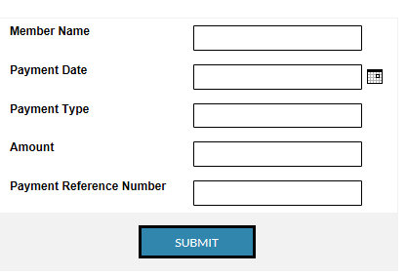

To report Membership counts and/or send out expiration emails go to the Membership Coordinator Menu and select Membership Report.
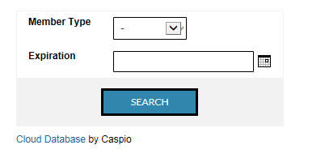

This will give you a count of all members or by each type when ran by type. If you run this report by Expiration the date is set as equal to or less than. Click on the Edit Grid at the top of the report and click the send email button. Once you have clicked all that you want an email to go to click the Exit Edit Grid at the top of the report and if they have an email in their profile they will receive an email reminding them to renew.

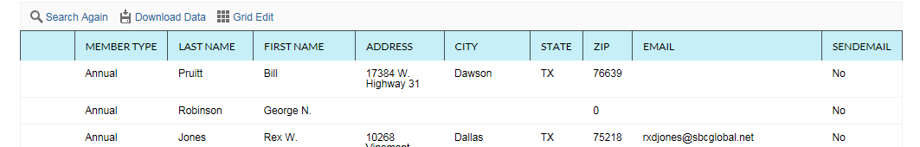

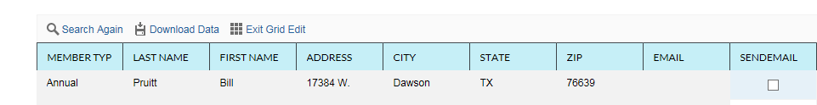

NOTE:
Members join through the following forms:

New User Registration
New Life Registration
New Corporate Registration
Member Renewal

New User and New Corporate set the expiration date at one year from date of join.
Life member sets the expiration to 12/31/9999.
Member Renewal sets the expiration for one year from current expiration date.
If a member pays for more than one year you will need to update the expiration date on their record through the Member Update process.
Each time a member joins or renews an email is sent to the Membership Coordinator.

