Go to the CASI website menu MORE/Event Coordinator/Event Approval

You have multiple ways to search for the events. If you just take the defaults and click search it will return all cook offs that have not been approved. The Date Submitted is set to give you anything that has been submitted on or before that date. So you can put in the 15th of the month that is the deadline date and it will give all that need to be approved that were submitted on or before the deadline.

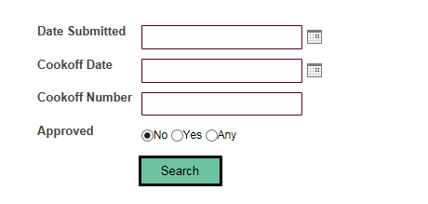

The list is sorted by cook off number. The cook off numbers are assigned at the time of submission so it is already sorted by what was submitted first. You can resort by using the Sort by in the upper right hand corner of the page.

Click on View Details to review the submission

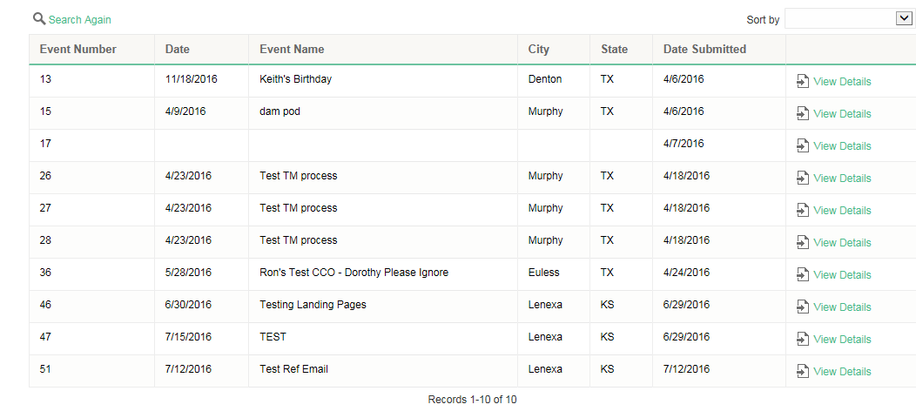

Review and make any necessary corrections. Be sure to set the region so that the Regional Referee is populated and they get an email when approved.
If for some reason you are not ready to approve this cook off you can click on the Search Again at the top left of the page and it will return you to the list.
Note: We do not have all regions or referees in the system. They will be loaded once we have all the 2016-2017 pod information.

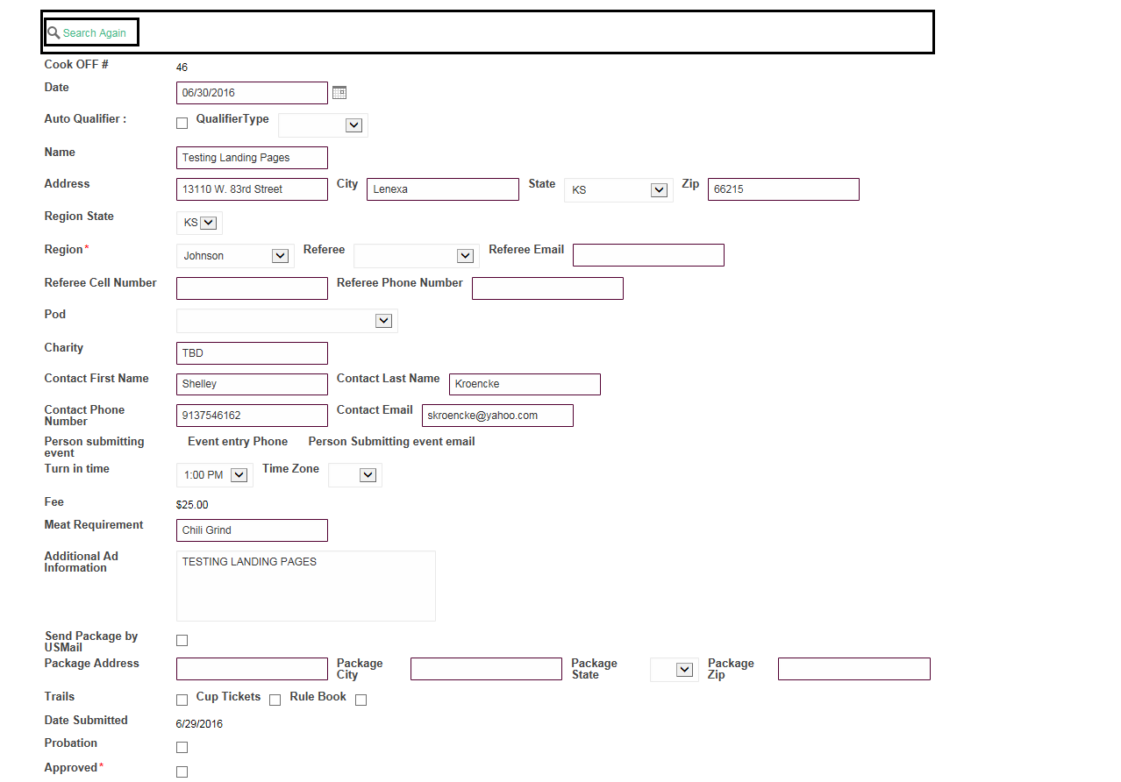

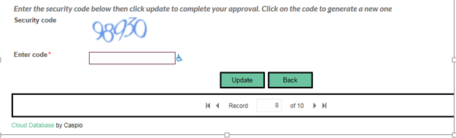

Once you click the Approved box, enter the Security code and click update the system will send out notices to the contact person and the referee that you set in the form. The event will then automatically show on the website event listing.

To make updates to already approved cook offs go to the same menu and choose Event Update.

Select by Date or number. Make the necessary changes and click update. A notice will go to the contact person and the referee listed.

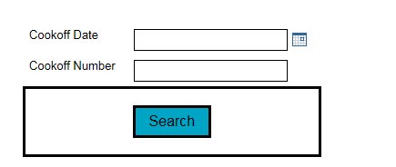

If you go to your Event Coordinator Menu and select Cook Off Count you will get a list of cook offs with a count of total at the bottom of the page. It will also sort by status so you can get a quick count of those that have been cancelled.

